Norfolk County Council (Flitcham with Appleton)
Emergency Notice

Temporary Traffic Regulation Order 2025
Section 14(2) of the Road Traffic Regulation Act 1984

Flitcham with Appleton (WTRO5786) Notice

In accordance with the provisions of Section 14(2) of the Road Traffic Regulation Act 1984, the Norfolk County Council HEREBY GIVE NOTICE that owing to burst water main the use by vehicles (of any class) of the Abbey Road from 290m northwest of its junction with A148 for 50m north-westwards (the “Road”) in the Parish of Flitcham with Appleton will be temporarily prohibited/restricted.

Alternative route is via: Abbey Road, Fakenham Road, Hillington Road, Anmer Road (Hillington, Flitcham with Appleton).

The closure/restriction is necessary because of the likelihood of danger to the public or serious damage to the road or both.

The closure/restriction is anticipated to take place from 2nd to 7th April 2025 but the Road may continue to be closed/restricted until the 22nd April 2025 where the closure/restriction is still required beyond the anticipated dates.

This Notice shall automatically revoke on the completion of the works / when the closure/restriction is no longer necessary or otherwise on the 22nd April 2025 without further notice.

If necessary, this Notice may be extended for an additional 21 days by further Notice and/or for a maximum of 18 months from the date this Notice is effective by further Order.

The works promoter for this restriction/closure is: Anglian Water.

A person who contravenes, or who uses or permits the use of a vehicle in contravention of the restriction/ closure imposed by the Order shall be guilty of an offence.

Penalty: £1000 maximum fine on conviction and/or endorsement for contravention.

Full details on the closure are available at https://one.network. Any enquiries that cannot be answered on the one.network website should be directed to the West Area Streetworks (Community and Environmental Services Department) contactable by telephone at 0344 800 8020 or email at streetworks@norfolk.gov.uk

Dated this 3rd day of April 2025.

Katrina Hulatt
Director of Legal Services (nplaw)
County Hall
Martineau Lane
Norwich
NR1 2DH

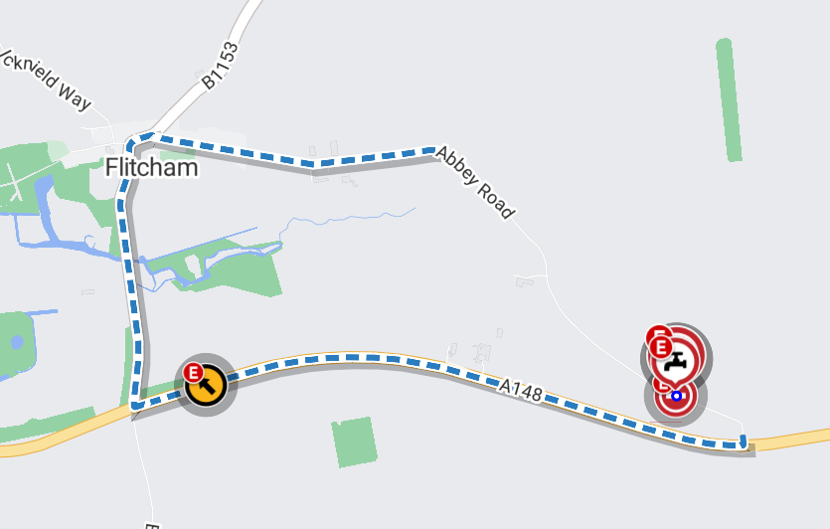
Map data © MapTiler © OpenStreetMap contributors

