Norfolk County Council proposes to make a Temporary Traffic Regulation Order (the “Order”) (WTRO5515) affecting the Lynn Road from its junction with Bircham Road to its junction with Stanhoe Road (the “Road”) in the Parish of Bircham to facilitate reinstatement works on carriageway, the Road will be temporarily closed (except for pedestrian access) for the duration of the works/period the closure is necessary which is anticipated to be from 16th to 17th April 2025, but may continue to be closed/restricted until the 29th May 2025 where the closure is still required beyond the anticipated dates.

Alternative route is via: Lynn Road, Anmer Road, Hillington Road, Fakenham Road, Sandringham Road, The Avenue, Manor Road, Chapel Road, Hunstanton Road, Snettisham Bypass, Heacham Road, Cole Green, Docking Road, Sedgeford Road, Bircham Road, Back Lane (Hillington, Snettisham, Docking, Ingoldisthorpe, Heacham, Dersingham, Flitcham with Appleton, Bircham, Sedgeford, Anmer, Sandringham).

The works promoter for this restriction/closure is: Norfolk County Council

Vehicular access will be permitted to a final destination in the Road where signs indicating such access is possible and permitted are in place.

The Order shall automatically revoke on the completion of the works when the closure is no longer necessary or otherwise on the 29th May 2025 without further notice.

If necessary, the restriction could run for a maximum period of 18 months from the date the Order is effective.

A person who contravenes, or who uses or permits the use of a vehicle in contravention of the closure imposed by the Order shall be guilty of an offence.

Penalty: £1000 maximum fine on conviction and/or endorsement for contravention.

In the event of the start date being delayed the new start date will be displayed on site in advance.

Full details on the closure are available at https://one.network. Any enquiries that cannot be answered on the one.network website should be directed to the West Area Streetworks (Community and Environmental Services Department) contactable by telephone at 0344 800 8020 or email at streetworks@norfolk.gov.uk

Dated this 4th day of April 2025.

Katrina Hulatt
Director of Legal Services (nplaw)
County Hall
Martineau Lane
Norwich
NR1 2DH

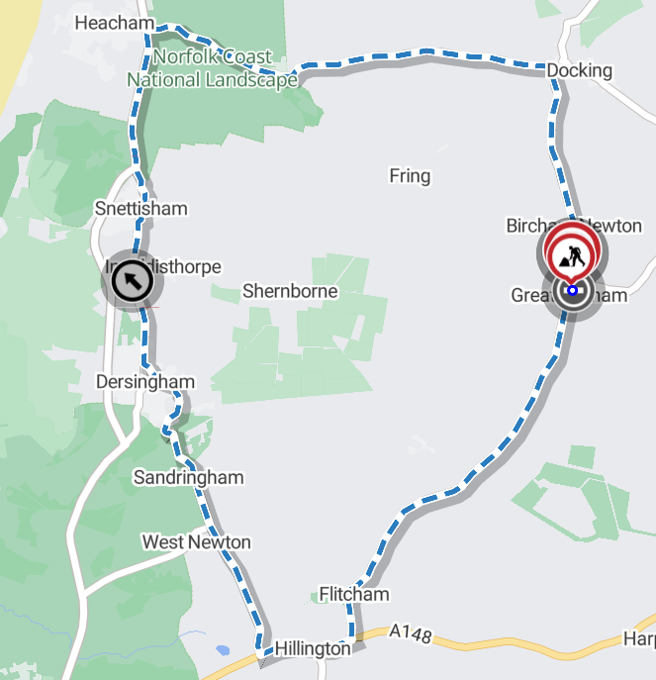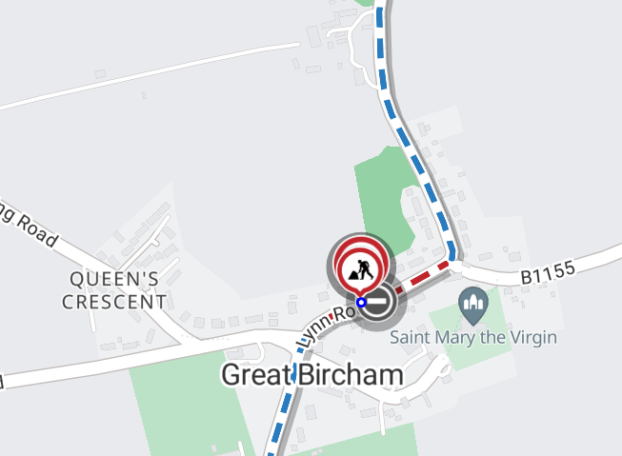
Imagery © 2025 maptiler | imagery © 2025 hexagon | © maptiler © openstreetmap contributor

