Norfolk County Council (Sandringham,
RHS Sandringham Flower Show)
Temporary Traffic Regulation Order 2026 – Notice

Section 16A of the Road Traffic Regulation Act 1984 (“RTRA 1984”)
as amended by the Road Traffic Regulation (Special Events) Act 1994
Norfolk County Council hereby gives notice that to facilitate the Sandringham RHS Flower Show, it intends to make an Order under Section 16A of the RTRA 1984 and all other enabling powers, with the consent of the Secretary of State the effect of which will be to temporarily restrict vehicular traffic on the:
- A149 Queen Elizabeth Way from its junction with the C79 Church Road for 100 metres northwards; and
- A148 Lynn Road from 100 metres east of its junction with the C56 West newton Road to its junction with the C56 West Newton Road;
- A149 Queen Elizabeth Way from 1 mile north of its junction with the A149 Knights Hill Roundabout for 4470 metres northwards;
- A148 Lynn Road from 4270 metres east of its junction with the A149 Knights Hill Roundabout for 1510 metres eastwards;
- B1440 Hillington Road from 310 metres south of its junction with the B1439 Lynn Road to its junction with the C82 Kings Avenue;
- C79 Scotch Belt from 200 metres west of its junction with the B1440 The Avenue for 750 metres westwards; and
- B1439 Lynn Road from its junction with the C70 Common Road to a point 170 metres east of its junction with the C56 Mill Road
in the Parishes of Sandringham, Flitcham with Appleton, Castle Rising and Hillington.
The Order shall be in effect (in force) from the 22nd to 26th July 2026 or until the restrictions are no longer necessary, whichever is earliest. The roads will be temporarily restricted (except for emergency and pedestrian access) for the duration of the Sandringham RHS Flower Show which is anticipated to be between 07:00 and 20:00 from 22nd to 26th July 2026. The restrictions specified will only have effect at such times and to such extent as indicated by the display of on-site signs.
While the Order is in effect:
- Traffic (constituting any class of vehicle) over the Road A will be temporarily restricted from turning right onto the C79 Folly Hill;
- Traffic (constituting any class of vehicle) over the Road B will be temporarily restricted from turning right onto the C56 West Newton Road;
- The Roads C-G will be temporarily subject to a 20 miles per hour speed restriction.
- Traffic (constituting any class of vehicle) over the Roads E and G shall be temporarily prohibited to park, stop, load, and/or unload.
The restrictions are anticipated to be in place:
- Between 08:00 and 11:00 over the Roads A and B
- Between 07:00 and 20:00 over the Roads C-H
There will be no alternative route.
The promoter of the event is the Royal Horticultural Society.
A person who contravenes, or who uses or permits the use of a vehicle in contravention of, a restriction or prohibition imposed by the Order shall be guilty of an offence.
Full details on the restrictions are available on the CausewayOne Network website. Any enquiries that cannot be answered on the CausewayOne Network website should be directed to the West Area Streetworks (Infrastructure Department) contactable by telephone at 0344 800 8020 or email at streetworks@norfolk.gov.uk
Dated this 24th day of June 2026

Katrina Hulatt
Director of Legal Services (nplaw)
County Hall
Martineau Lane
Norwich
NR1 2DH

Plan of Restrictions
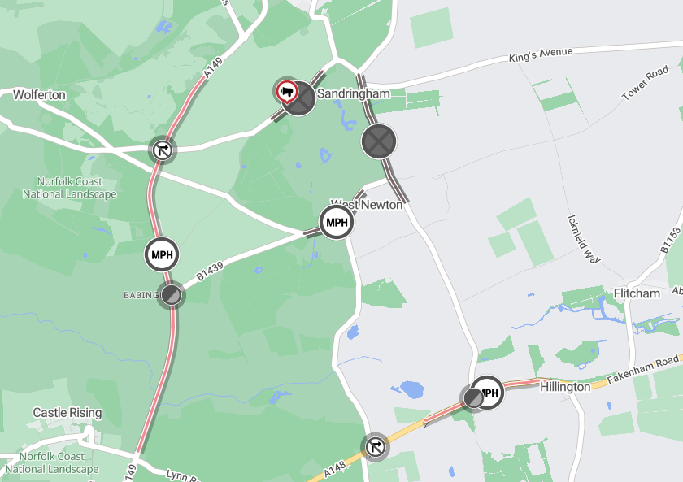

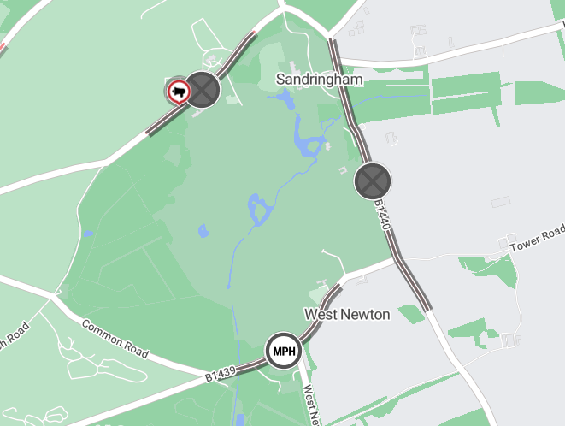
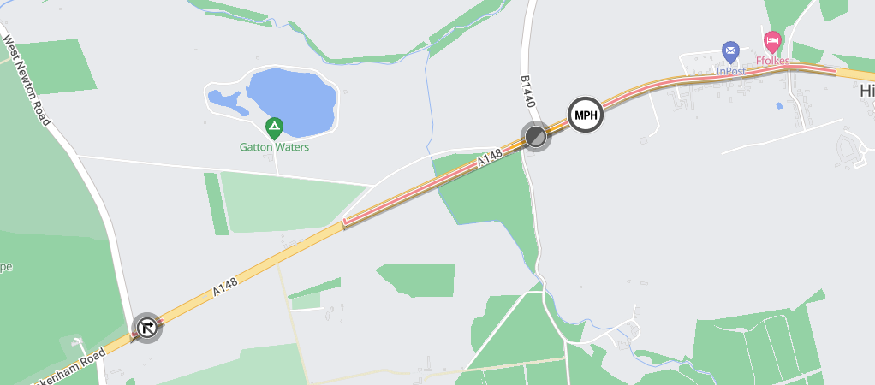
Imagery © 2026 MapTiler | Imagery © 2026 Hexagon | © MapTiler © OpenStreetMap contributors

